
MATHS METHODS 3 & 4
TRIAL EXAMINATION 1
SOLUTIONS
2007

Question 1

The function 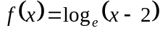 is defined for
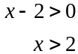
So 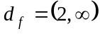
(1 mark)

Question 2

- 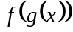 exists iff 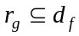.
Now, 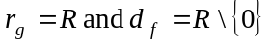.
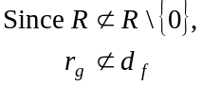
so does not exist.
(1 mark)

b. i.
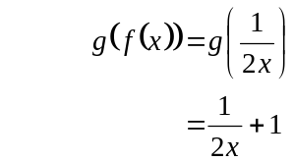
(1 mark)

ii.
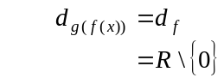
(1 mark)

Question 3

a. 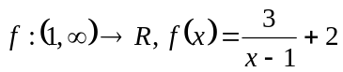
Let 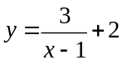
Swap x and y
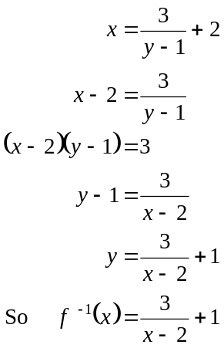
(1 mark)
(1 mark)

  - 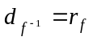
Do a quick sketch of

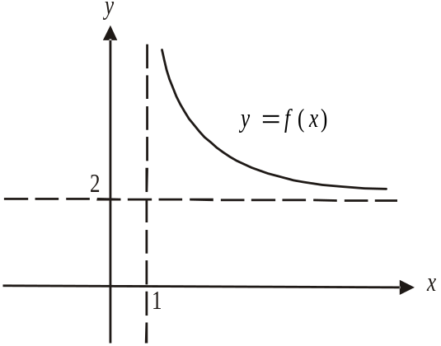

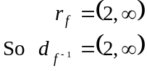
(1 mark)

Question 4

- 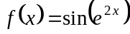
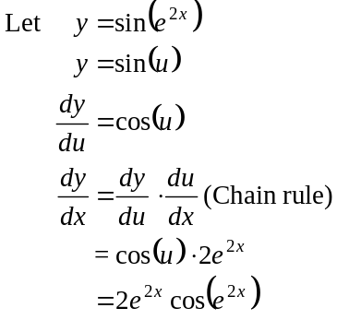
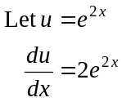
(1 mark) – for knowing to use the chain rule
and attempting to use it
(1 mark) – correct answer

b.
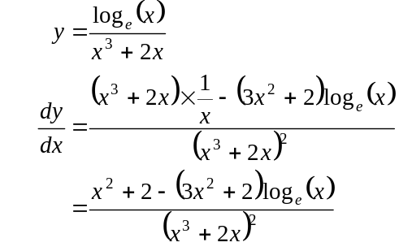
(1 mark) – for knowing to use the quotient rule
and attempting to use it
(1 mark) – correct answer

Question 5

For 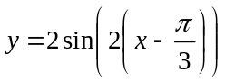 the period is 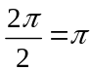 (1 mark) correct period
This means that for 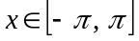 there will be two complete periods of the graph.

x-intercepts

Method 1
The graph is a sine graph with a period of that has been translated 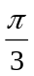 units to the right so that the x-intercepts will occur at 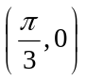, at 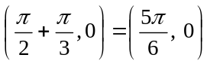, at 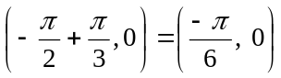 and at 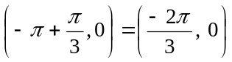. (1 mark) for x- intercepts

Method 2
The x- intercepts occurs when 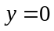.
becomes
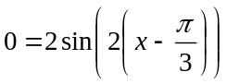
So, 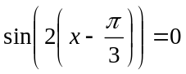
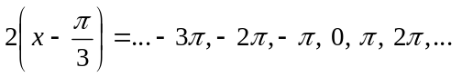
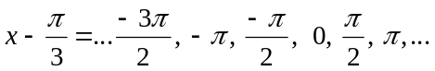
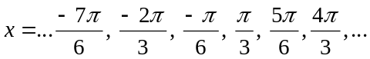
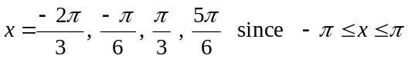
(1 mark) for x- intercepts
y - intercept 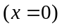
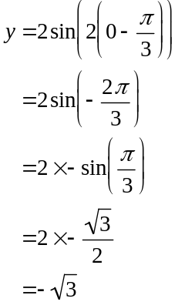 Angle measured clockwise because it is negative.
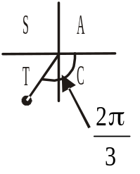
y-intercept occurs at 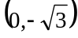 (1 mark)
To find the endpoints:

Method 1
Because two complete periods occur for 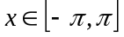 the right endpoint and left endpoint will have the same y-coordinate and it will be the same as the y-intercept.
So left endpoint is 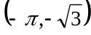 and the right endpoint is 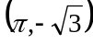.
(1 mark)

Method 2
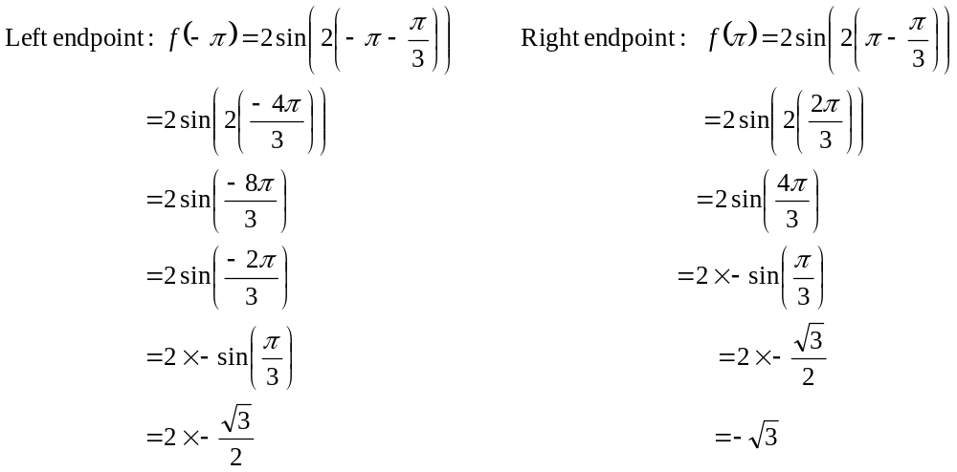
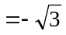
Left endpoint is 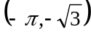. Right endpoint is .
(1 mark)

The graph of is shown below.

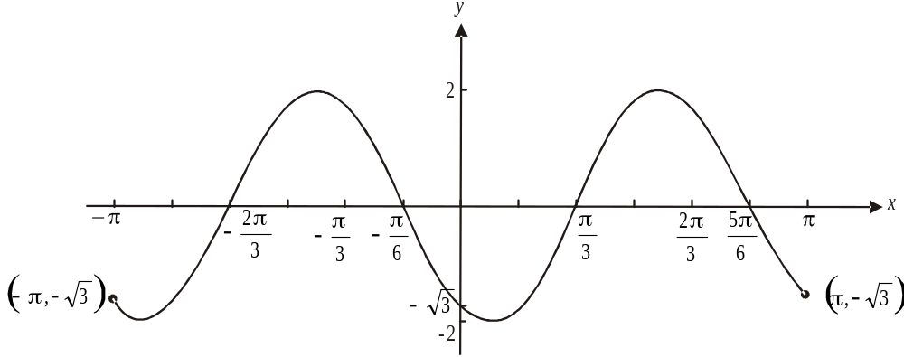

(1 mark) correct shape including amplitude

Question 6

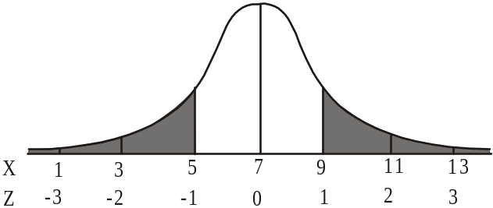

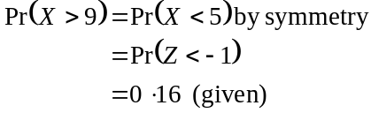
(1 mark)

- 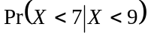 (conditional probability)
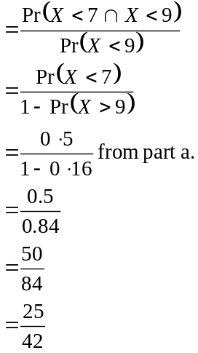
(1 mark)
(1 mark)
(1 mark)
Question 7

- Since 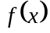 represents a probability density function then
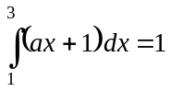
(1 mark)
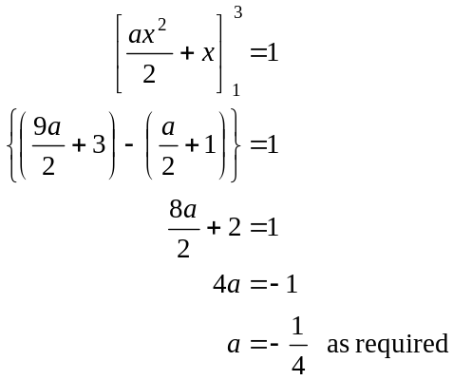
(1 mark)

b.
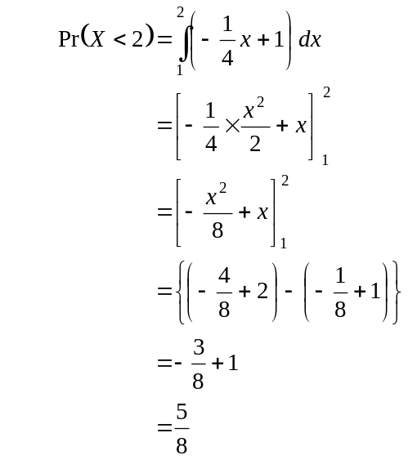
(1 mark)
(1 mark)

Question 8

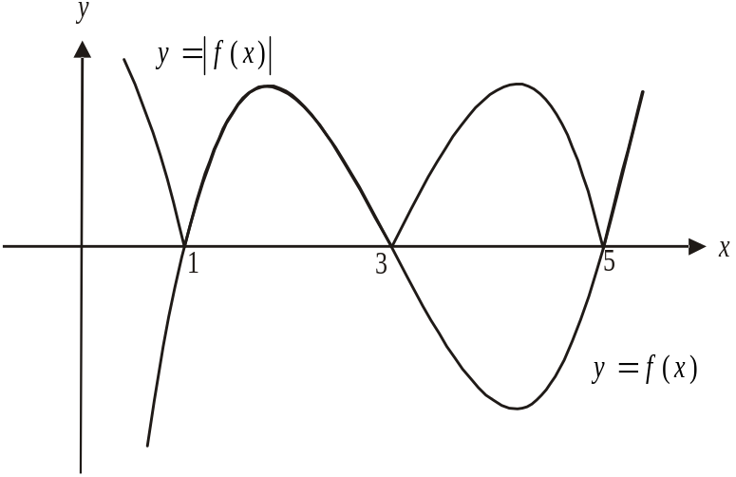

Note that at the points 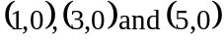 the graph of 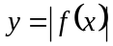 has cusps; i.e. “pointy bits” not smooth curves since the graph of 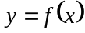 is being reflected in the x-axis.
(1 mark)

- 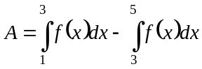
(1 mark)

Question 9

a.
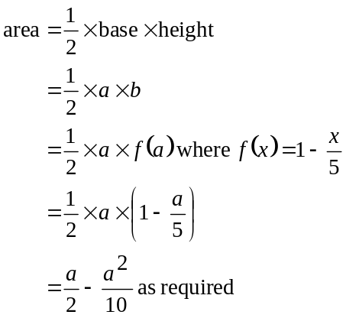
(1 mark)
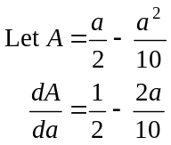
b.

(1 mark)
Maximum occurs when 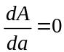
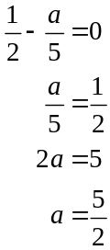
Note: we know we have a maximum because the graph of the function 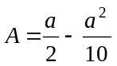 is an inverted parabola.
We have a maximum when 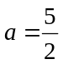. (1 mark)

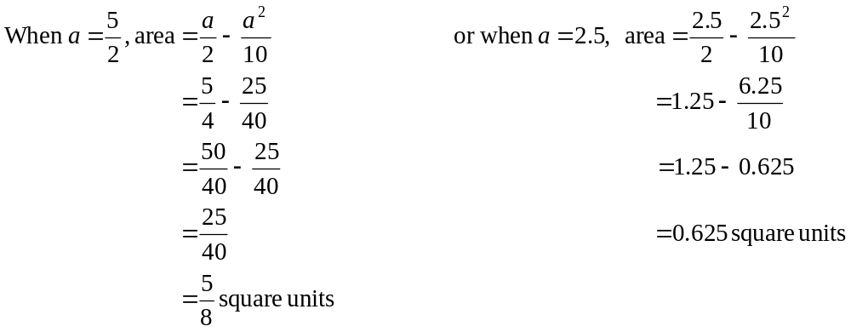
(1 mark)
Question 10

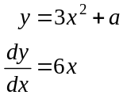
The gradient of a normal to 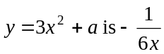.
(1 mark)
Also the gradient of the normal 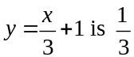.
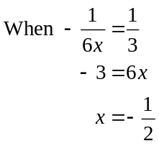
(1 mark)
The x-coordinate of the point where the normal hits the curve is 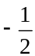.
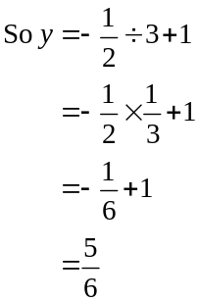
The curve and the normal both pass through the point 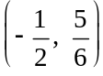.
Substituting this point into
(1 mark)
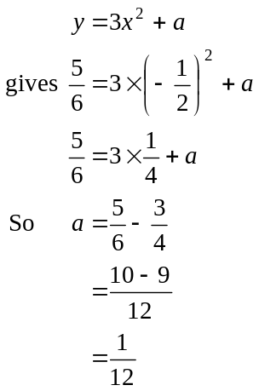
(1 mark)

Question 11

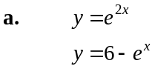
At the point of intersection of the graphs,
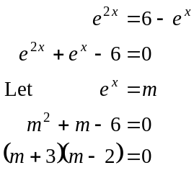
(1 mark)
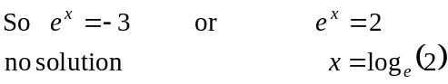
The x-coordinate of the point of intersection is 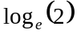.
(1 mark)
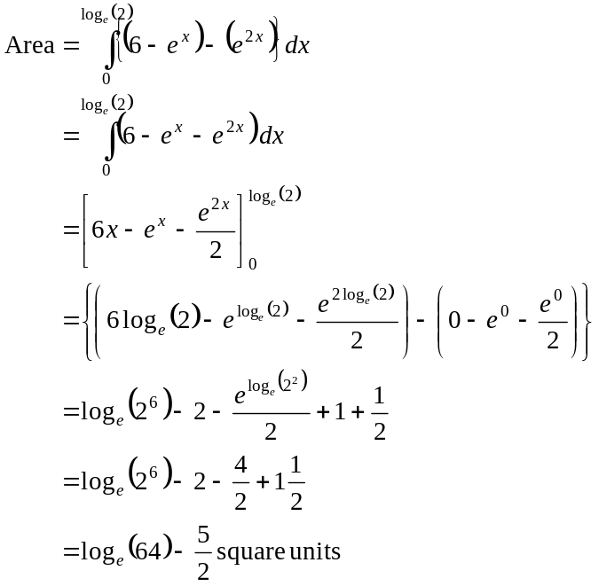
- a
(1 mark)

(1 mark)

(1 mark)

(1 mark)

Total 40 marks

